**Innovation with Machile Learning.**

**Introduction.**

In previous modules, we explored the critical role that data plays in digital transformation.

I also covered the importance of how you can collect, store, and access data to enable effective data driven decisions.

Volumes of data and the right cloud based tools are the foundation for using machine learning and artificial intelligence or ML and AI.

To set the foundation for this module, I'll begin with the definition for ML and AI.

Then I'll cover some important data quality considerations that influence the efficacy of machine learning models.

Finally, I'll highlight several real world use cases in which customers have leveraged ML to radically transform their business.

Let's begin.

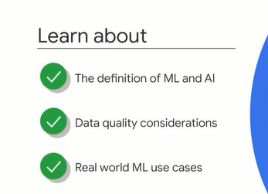

**What is machine learning?.**

To understand machine learning, you have to start by thinking about data in your business. Do you have a dashboard that analysts view every day? Or maybe there's a report that your managers review each month. Both the dashboard and the report are examples of backward-looking data. They look at what happened in the past. Most data analysis in your organization is probably backward-looking, analysis of historical data to calculate metrics or identify trends. But to create value in your business, you need to use that data to make decisions for future business.

Let me give you an example.

Suppose Maya leads the business strategy and operations team for an international airline. She might be looking at historical annual reports to establish a trend in customer purchasing patterns. She'd probably use this data to forecast annual sales and operational costs, but there's nothing new or transformational about this decision-making process. What if Maya could predict the satisfaction rate of each flight or predict customer complaints and get ahead of them? To do this effectively, she'd need to access a lot more data, including number of passengers per flight, duration of each flight, customer satisfaction ratings per flight, number of customer complaints per flight, factors that contributed to customer complaints, weather reports, seasonal indicators, and time to resolution for customer complaints. With all of these various data points, she might be able to predict the quality of a single flight and its customer complaints, but there are hundreds of flights each day. The real value for Maya would come from being able to make predictive insights for all flights all year round. More importantly, it would be far more valuable if she could dynamically adjust pricing or staff assignments or even catering based on the predictions. ML unlocks these capabilities and more.

But what exactly is machine learning?

**To understand that, we need to step back and define artificial intelligence first. Artificial intelligence, or AI, is a broad field or term that describes any kind of machine capable of acting autonomously.**

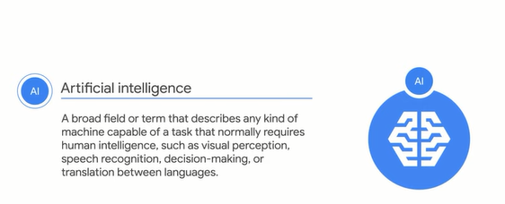

**Machine learning or ML is a specific branch within that field.**

Specifically, **ML refers to computers that can learn from data without using a complex set of rules**.

Machine learning solves many kinds of problems.

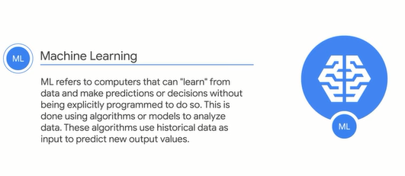

For the purposes of this course, we'll focus on a definition of ML that applies to numerical or classification problem types.

I'll use this ML definition to guide your learning throughout the module, and here it is.

ML is a way to use standard algorithms or standard models to analyze data in order to derive predictive insights and make repeated decisions at scale.

Put simply, it's a way of teaching a computer how to solve problems by feeding it examples of the correct answers.

Usually these problems are about predicting something.

For example, you can predict how long it takes to travel from one location to another by feeding the computer examples of the completed journeys.

Similarly, you can predict the estimated taxes owed by feeding the computer examples of tax filings.

You'd do the same for predicting weather patterns over the next few days.

More technically speaking, suppose you wanted to use machine learning to accurately label a photo of a fruit or vegetable the model has never seen before.

You train an ML model or the standard algorithm using lots of images of fruits and vegetables, input data, and their correct labels, output data.

As you train the ML model with more input data and corresponding output data, its predictions become more accurate when you feed it an image of a fruit or vegetable it hasn't seen before.

Now that was an overly simplified example.

We'll cover many more real-world examples throughout the module.

Ultimately, the purpose of ML in a business is the same as all other disruptive new technologies-- to enable organizations to better achieve their missions.

To apply machine learning effectively, you need lots of data.

In fact, you need lots of high-quality data to generate more and more accurate, meaningful predictions.

In the next video, I'll examine factors that impact data quality.

**Data Quality.**

In the previous video, you learned that ML is a way to use standard algorithms or models to analyze data. This analyzed data can be then used to derive predictive insights and make repeated decisions. The accuracy of those predictions, however, depend on large volumes of data

that are free of bugs. Let me use a software analogy to explain what I mean by bugs. In traditional software development, a bug is a mistake in the code that causes unexpected or undesired behavior. In ML, even though there can be bugs in the implementation of an algorithm,

bugs in data are far more common. Consider this example. A few years ago, some Googlers wanted to use ML to help diagnose diabetic retinopathy, which is the fastest growing cause of blindness, potentially affecting more than 415 million diabetic patients worldwide. Working closely with doctors in the US and India,

these Googlers created an ML model that would diagnose diabetic retinopathy almost as well as ophthalmologists can. They trained an ML model using labeled images of the backs of eyes, each label being the diagnosis. Because humans were involved in the labeling of the images, the labeling system is not completely objective.

The data may have included incorrect labels or even human bias, which is then propagated into the ML model itself. So how would you ensure that you have optimal data quality when training an ML model? The best data has three qualities. **One, it has coverage. Two, it's clean or consistent. And three, it's complete.**

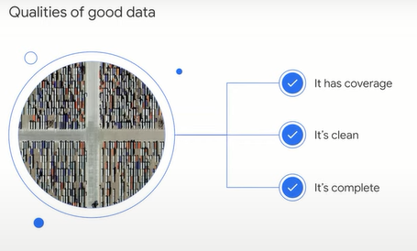

I'll explain each one.

**Data coverage** refers to the scope of a problem domain and all possible scenarios it can account for. In other words, all possible input and output data. Let's imagine an auto manufacturing use case where the goal is to use ML to automatically identify defects in car parts.

Let's assume also that the car parts are divided into red and blue. If red and blue make up all the possible scenarios, but you only train your model with red parts, the model might not be able to detect defects in blue car parts when it's presented with new data.

So more data and broader coverage produce a more accurate ML model.

The second quality of good data is its **cleanliness**. This is sometimes called **data consistency.** Data is considered dirty or inconsistent if it includes or excludes anything that might prevent an ML model from making accurate predictions. This is a lot like the errors or bugs we talked about earlier.

The simplest form of inconsistency in data is data format. Suppose, for instance, you want to analyze data from multiple documents, and one of the data points on each document is a timestamp. The timestamps from all sources have to be of the same format, otherwise the data is considered dirty.

Let's return to our manufacturing scenario. Where do you think inconsistencies could occur? Well, if you're using photos to look for defects in car parts, you need to be careful with which images you choose to train the model. For example, if the images have shadows in them, the model won't know whether shadows

are part of an object or not. If you want to make predictions from images that are supposed to have shadows, that's okay-- otherwise your data is dirty. I mentioned incorrect labels earlier, which is another form of dirty data. In this scenario, you might have parts that were labeled as fractured, but in reality they were discarded because they were the wrong size. There are lots of examples of human error that causes dirty data as well. Imagine the sales and retail industry, for example. If someone enters incorrect purchase data in a data storage system, this creates dirty data. If there's an error in an automated service, or if a transaction is recorded incorrectly every time the register runs out of paper, this also produces dirty data. The more incorrect or dirty data you have, the more correct and clean data you'll need to provide a counterbalance so the ML model learns the correct outcome.

Another quality of good data is **completeness**.

This refers to the availability of sufficient data about the world to replace human knowledge. Think of this as the various data categories or themes that help complete a user's profile such as address, gender, or height. Incomplete data can limit the performance of an ML model. We say there's incomplete data when there's a lack of better data, there are mistaken expectations about how ML works and what it's capable of, or program design and implementation are poorly executed. Let's go back to our manufacturing example. Imagine that one of the major sources of defects is overheating, but you're not collecting temperature data.

That's an example of incomplete data. Even if you start collecting temperature data now, you may not have the historical data that maps to past examples of good and fractured parts. Another form of incomplete data is the number of cases for all possible scenarios the data is intended to cover.

In the same manufacturing example, your goal is to match the labels, good condition and fractured, with every part. If axle is one item you're evaluating for defects, you'll need examples of axles in good condition and fractured. If you don't have that data, your data is incomplete. Remember--data is the tunnel through which your model views the world. Anything the model can't see it assumes doesn't exist. For example, if a model was given an image that only showed what's on the left, it might think the road was open and traffic free. In reality, if I show you the full image, the road is just closed. The good news is that most of these problems can be solved simply by getting more data, but you have to be purposeful in collecting that data. Do you need to improve coverage, improve cleanliness or consistency, or improve completeness? Remember--data is central to ML.

If you're planning to use it, you'll need to account for as many possibilities when preparing your data before training an ML model. Now you might be wondering what kinds of skills or expertise you need to begin using machine learning in your organization. Before you go too far down that path,

I want to reassure you that ML has become more accessible than you think. In the next video, I'll explore some Google Cloud ML solutions that you can use-- some even right away-- to bring new value into your business.

**AI and ML with Google Cloud.**

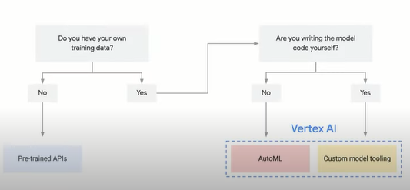

People often assume that you need a robust technical team that includes data analysts, data engineers, and even ML engineers to leverage the capability of Cloud and ML. They also assume that only then can you build custom ML models that meet your organization's needs. This can seem costly and daunting.

The reality is that ML is more accessible now than ever before. In fact, Google Cloud democratizes AI by providing a range of ML and AI solutions that enable businesses to leverage the power of ML and AI without their traditional costs and efforts. Depending on your organization's data science expertise and needs, Google Cloud ML and AI offerings provide the options to use a pretrained ML model using Google's data such as Vision API, train an existing ML model with your own data, build a custom ML model and train it using your own data. For example, Google Cloud AI Platform is a unified simply-managed platform that makes machine learning easy to adopt by analysts and developers. It's not limited to data scientists. It provides modern ML services with the ability to generate your own tailored models and use pretrained models so that you can add innovative capabilities to your own applications.

It also includes the Google Cloud AI Hub, a hosted repository of plug-and-play AI components. If you have data scientists who are already working with ML, they might already be using TensorFlow. It has a comprehensive, flexible ecosystem of tools, libraries, and community resources. TensorFlow lets researchers push innovation in ML and lets developers easily build and deploy ML-powered applications. It was first developed for Google's internal use, but it's now open-source so that everyone can benefit. TensorFlow can also take advantage of tensor processing units or TPUs, which are hardware devices designed to accelerate ML workloads with TensorFlow by 15-30x. Google Cloud makes them available in the Cloud with Compute Engine virtual machines. Each Cloud TPU offers a large amount of performance, and because you pay only for what you use, there's no upfront capital investment required. If your data scientists need to work on a new problem, Google's AI Hub has notebook samples they can use to learn about, train, and deploy the new model they need. The AI Hub is a hosted repository of plug-and-play AI components, including end-to-end AI pipelines and out-of-the-box algorithms. Google Cloud AI Platform is a fully managed machine learning service that allows Cloud customers to create machine learning models, train them, and use them to integrate predictive analytics into their applications and data processing pipelines. Suppose you don't have specialized data scientists but do have business analysts and developers. What do you do? This is where our machine learning as a service and platform as a service offerings are useful. Google Cloud can help app developers build smart apps using application programming interfaces or APIs. APIs are simple methods and tools to connect various applications. They can be deployed in a virtual private Cloud, on-premises, or in Google's public Cloud. They allow developers to quickly and easily train custom models regardless of their level of experience. To better understand this, let's imagine a developer building a mobile app that users will submit photos to. The developer needs the app to recognize what the images are and filter out any that aren't safe for work. With AI Hub, the developer can search for a suitable API and easily incorporate an ML service into their project.

For instance, the developer might choose Vision API. This offers powerful pretrained machine learning models using Google's data to automatically detect faces, objects, texts, and even sentiment in images. The developer can therefore use Vision API to assign labels to images and quickly classify them into millions of predefined categories.

But categorizing images is sometimes more complex. Think back to our example from the previous video where ML was used to recognize defects in car parts. Vision API can tell the difference between generic images found in Google's database, like the difference between a wheel and an engine, but it won't be able to identify good or defective parts for a specific car manufacturing company. In this case, a developer could use AutoML Vision API. This API automates the training of your own custom machine learning models. This means a developer can simply upload a custom batch of images or ingest them into AutoML Vision directly from Cloud Storage and train an image classification model with the easy-to-use graphical interface. Models can be further optimized and deployed for use directly from the Cloud. The APIs covered in this module that enable access to ML and AI services are just a small sample of Google Cloud offerings.

You can also find APIs for categorizing videos, converting audio to text or text audio, understanding the natural language, translating from one language into another, and so much more. In fact, many of the most innovative applications for machine learning, several of these kinds of applications are combined. For example, what if whenever one of your customers contacted your call center your application could automatically answer simple queries in natural language and route more complex queries to an agent? The Google Cloud AI Platform makes that kind of meaningful interactivity possible. Another example is the Google Translate API. You might already be familiar with Google Translate, a free service available instantly via search when you type in, for example, dog in Spanish. The API allows global businesses to access the ML service to provide localized information to their customers and employees in real time. You've now learned that there are many different opportunities to use ML and AI with Google Cloud to transform your day-to-day work. The ability to leverage ML is now accessible across the organization through APIs that enable innovation and help businesses achieve their mission. In the next video, I'll cover some common opportunities for using ML in day-to-day business and highlight some real-world examples where businesses have transformed using Google solutions.

**Real-world use cases for ML.**

So far, we've defined machine learning, reviewed the importance of quality data, and explored a few Google ML and AI offerings.

In this video, I'll cover four common business problems that ML is particularly suited to solve.

In each case, ML is uniquely placed to create new business value when it can learn from data to automate action and processes and to customize responses to behavior.

The four common business problems are **replacing or simplifying rule-based systems, automating processes, understanding unstructured data, and creating personalized customer experiences**.

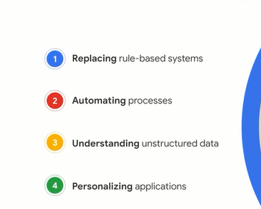

Let's start with the rule-based systems.

I'll use Google Search as an example.

Suppose, for instance, you want to search for the Giants, a sports team.

Ah, but wait, if you type in "giants," should the search results show you San Francisco Giants or New York Giants?

One is a baseball team based in California, the other is an American football team based in New York.

A few years ago, the search engine code base used hand-coded rules to decide which sports team to show a user.

If the query is giants and the user is in the Bay Area, show them results about San Francisco Giants.

If the user is in the New York area, show them results about New York Giants.

If they're anywhere else, show them results about tall people.

This is for just one query.

If you multiply this by thousands of different queries and by different users each day, you can probably imagine how complex the whole code base would become.

This is a perfect problem for ML to solve.

If we had all of the data that tells us which search results users clicked on per query, why not train a machine learning model to predict the rank for search results?

That was the idea behind RankBrain, Google's deep neural network for search ranking, which was introduced in 2015 by Google's engineers.

It outperformed many human built signals and, using ML, Google was able to replace many of the hand-coded rules.

The neural network ended up improving search quality dramatically.

In fact, Google's neural network is a key differentiator among similar technologies in the market.

An added benefit of RankBrain or any machine learning model is that the system could continually improve itself based on new user queries and new user clicks.

Search is one example of how ML leverages vast amount of data to provide highly accurate predictions in a rule-based system.

A second opportunity for using machine learning is to automate processes where ML makes predictions and repeated decisions at scale.

Let's look at an example.

Ananda Development is a property developer headquartered in Thailand that decided to use ML to automate the handover stage of their property sales.

Before embracing cloud and ML, the handover process included multiple manual steps and was prone to errors.

In any sale before the buyer paid for the property, an Ananda development inspector and the buyer had to conduct a detailed check of the condominium for any building variations that needed to be fixed.

Ananda development inspectors would visually check hundreds of items a day for problems and list any issues on paper.

Prospective buyers might also take notes and photographs of the findings.

On average, a single inspector would have to check several hundred items per day.

Multiplied across several inspectors and multiple projects, this workload adds up.

This laborious manual process was also subject to occasional human error.

That meant data could be omitted or recorded incorrectly.

Ananda Development decided to build an app using machine learning to make the inspection process more efficient.

The app used Google Speech-to-Text API to recognize and convert Thai language speech in a version of English spoken by many Thai people to text.

The company found the product had an accuracy rate of over 90 percent in recognizing Thai speech and high accuracy rates in recognizing Thai English.

The inspection process is now more efficient and accurate.

As another benefit, buyers also receive copies of electronic inspection reports and updated status notes as defects are repaired.

Another class of ML use case is for understanding unstructured data like images, videos, and audio.

Before I dive into examples of how you can use ML to understand unstructured data, I need to acknowledge a key point.

So far in the module, we've been talking about a specific type of ML that uses structure data to make predictions at scale.

Now I'm going to cover how ML can also be used to understand unstructured data.

Unstructured data is data that can't be directly compared to other data.

For example, some characteristics of books are structured like the title, their publisher, location of publishing, number of pages.

Again, this is known as tabular data, but it's not easy directly to compare the content of the two books or to precisely determine how they are related or different.

Even human experts might not agree on exactly how similar two books are.

Open text or language is just one example of unstructured data.

Other examples include pictures, videos, and audio.

A great example of using ML for unstructured data comes from Ocado.

Ocado is one of the world's largest online-only grocery supermarkets.

Previously, all email sent to Ocado would go to a central mailbox for sorting and forwarding by a person.

This process was time-consuming and would lead to a poor customer experience.

To improve and scale this process, Ocado used ML to automatically route emails to the department that needs to process them.

This new process eliminated multiple rounds of reading and triaging.

Here, Ocado used ML to both automate a process and understand unstructured data.

Specifically, they used ML's ability to process natural language to identify the customer sentiment and the topic of each message so they could route it immediately to the relevant department.

Now let's look at a fourth example, personalization.

Many businesses use ML to personalize user experiences.

Personalization is the difference between a newspaper and an email.

A newspaper article can be interesting, but it's written to appeal to thousands or millions of people.

However, an email is often tailored just to one person by including their name, for example.

YouTube is a great example of personalization in action.

When you watch a video on YouTube, you're probably noticed on the homepage or to the right of your video, there's a list of recommended videos that are up next.

When your video finishes, these new videos will play.

And we'd like them to be interesting and useful for you.

This feature keeps the user interested and engaged with the product.

By providing personalized recommendations using ML, YouTube can deliver a better service to their customers while also increasing their ad revenue.

Many businesses use the same approach to feature product recommendations on their websites personalized to individual users.

Other businesses use personalization to surface new content like music recommendations or films to stream.

Great, let's do a recap.

So far, I discussed some common applications of machine learning such as replacing rule-based systems, automating business processes, understanding unstructured data, and personalizing applications.

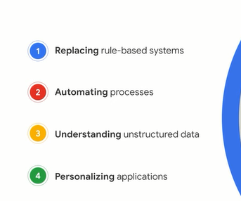

It's important to remember that ML models aren't standalone and that solving complex business challenges requires combinations of models.

There are, of course, many more applications of machine learning for businesses, and you can learn even more about them in the course Managing Machine Learning Projects with Google Cloud.

Next, I'll summarize the key topics we covered in this course.

**Quiz.**

1. Which of the following describes data completeness? Select the correct answer.

The problem scope or knowledge domain that the data covers

A collection of 10 or more datasets about a domain to replace human knowledge

**The availability of sufficient data about the world to replace human knowledge**

Anything that can prevent the ML model from accurately predicting the correct outcome

2. One characteristic of high quality, bug-free data is that it has coverage. What are the other two qualities? Select the **two** correct answers.

Clarity

**Cleanliness**

**Completeness**

Structure

Simplicity

3. Machine learning is a subset of which body of knowledge? Select the correct answer.

Automated intelligence

**Artificial intelligence**

Virtual reality

Augmented reality

4. The finance team just posted an open role for a Financial Manager. Jessica, the recruiter, wants to use a machine learning (ML) model to predict when the new position would be filled. Why is this use case not suitable for ML? Select the correct answer.

Once the prediction is made, the ML model is no longer useful.

**This is an infrequent decision for a specific role and department.**

Jessica would need access to sensitive employee data to train a custom ML model.

The problem statement is too vague and wouldn’t benefit the overall company.

5. Olivia wants to use a machine learning (ML) model to categorize product images from social media and use that information to make predictions about future products. Her team includes experienced developers, but no specialized data scientists or ML experts. Which Google Cloud solution can they leverage to do this? Select the correct answer.

AI Platform Training (formerly known as Machine Learning Engine)

**Google’s APIs on Google Cloud's AI Hub**

Tensor processing units (TPUs) for running TensorFlow

Notebook samples from Google Cloud's AI Hub

6. What are two common business problems that machine learning solves? Select the **two** correct answers.

Restructuring inefficient internal processes

**Creating personalized customer experiences**

**Automating processes**

Identifying competitor differentiation

Leveraging underutilised employee talent

**Summary.**

Congratulations for completing this course.

We've covered a lot, so let's review the key points.

You learned that data is any information that is useful to a business, from a number on a spreadsheet to an idea in an employee's head.

Leveraging that data to digitally transform a business is vital for thriving in the Cloud era.

Organizations can now ingest, analyze, and use that data at a speed and scale that wasn't possible before.

This is possible with different types of data, unstructured and structured.

You also learned about databases, data warehouses, and data lakes as key concepts and solutions for storing, processing, and managing data.

In particular, you learned about Google Cloud Solutions, including Cloud SQL, Cloud Spanner, Cloud Storage, and BigQuery.

By building and using the right systems that effectively store, access, and combine data, companies can also leverage their data for machine learning.

You then learned about businesses that are using ML and disrupting their industries by replacing rule-based systems, automating processes, understanding unstructured data, and creating more personalized experiences for users.

As you consider ML and AI applications for your business, I want you to remember a very important point; wherever there's data, there's inherent human bias.

Make sure to build an ethical and responsible Best Practices as you start working with AI and ML.

You can learn more about the types of biases and best practices to mitigate them in the Managing Machine Learning Projects with Google Cloud Course.

For more courses, check out the Google Cloud Training Catalog at cloud.google.com/training.

And if you signed up for the learning path, be sure to complete all four courses to get credit.